Vanier College

Faculty of Science and Technology

**GallerieM**

System Development

420-942-VA

Deliverable 01

2023-09-15

**Red Team**

Justin Elmourne

Florjan Blakaj

David Lafleur

Roy Aldner Labado

Seyed Ali Ashrafizadeh

We, the Red Team, certify that this assignment is our own work

I, David Lalfeur, student ID# 0110341, certify that I have contributed to this

deliverable, D.L.

I, Justin Elmourne, student ID# 1755556, certify that I have contributed to this

deliverable, J.E.

I, Florjan Blakaj, student ID# 2395017, certify that I have contributed to this

deliverable, F.B.

I, Roy Aldner Labado, student ID# 2395053, certify that I have contributed to this

deliverable, R.L.

I, Seyed Ali Ashrafizadeh, student ID# 2395024, certify that I have contributed to this

deliverable, A.S.

TABLE OF CONTENTS

**Overview 4**

**Client 5**

**Team Organization 6**

Meeting Schedule 6

Repositories 7

Communication 8

Synchronous Meetings 8

Areas of Responsibility 8

Contact Information 9

Client Contact 9

Reports 10

**Project Plan 11**

# 

# **Overview**

We are excited to present our project, a prototype eCommerce web application for our valued client Meenusha , who operates a small business, GallerieM, in Montreal. Gallerium specializes in handmade and personalized items.

To create the prototype, we have established a collaborative approach with regular in-person meetings to discuss project status, planning, and task assignments. Ongoing client meetings will ensure we meet dynamic demands and keep our client, Meenusha, informed about project progress. Justin Elmourne will serve as the primary point of contact for client communication. Our team will use Microsoft Teams/Discord for communication and GitHub for shared cloud storage/repository. Project planning and tracking will be facilitated through Microsoft Project, detailing tasks, estimated work times, start/end dates, sequencing, and team member assignments.

A new team leader will be assigned for each deliverable, allowing for diverse leadership experiences. Task assignments will consider team members' capacities and skills, with flexibility for changes due to external factors. Certain responsibilities, such as minutes reports and client communications, will remain consistent throughout the project to maintain clear progress tracking and client communication.

Our team is committed to delivering a successful prototype for Gallerium's eCommerce web application. We look forward to ongoing collaboration with Meenusha and anticipate a successful project outcome.

# **Client**

Our client Meenusha, runs a small business on Instagram where she and her sister sell custom hand made products ranging anywhere between shirts, cups, cards, and other handmade products. Additionally, her clients can request any type of embroidering or text on her merchandise.

Meenusha, when not running her business, is a lawyer full-time and does custom products as a hobby. However, after I reached out she mentioned that her business has stagnated and wanted to reach a larger audience through a website and streamline the whole process of buying and selling products.

The client gave more details about the website and came to a conclusion that she wanted an eCommerce website where clients can choose from a variety of predetermined products as well as an option to get handcrafted items not already present on the page. Moreover, she wanted the website to showcase some of her artwork and collection that appears on her Instagram page, similar to an art gallery.





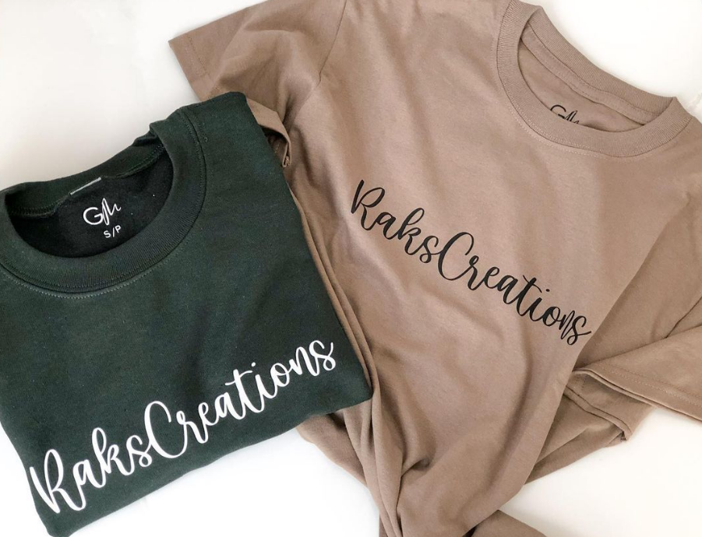

# 

# Team **Organization**

## **Meeting Schedule**

The schedule we have set for ourselves goes as follows:

* Wednesday Asynchronously
* Friday In Class
* Other meetings are optional

Sample agendas, pulled from our first, second and third meetings are as below:

### First Meeting

|  |  |  |
| --- | --- | --- |
| **Tasks** | **Status** | **Progress(%)** |
| Created the team groups and divided up the work | Completed | 100 |
| Created a GitHub repository and cloud storage | Completed | 100 |
| Added teams members as collaborators | Completed | 100 |
| Discussed Plan of action for finding clients | Completed | 100 |
| Looking for potential clients | In Progress | - |

### Second Meeting

|  |  |  |
| --- | --- | --- |
| **Tasks** | **Status** | **Progress(%)** |
| Sent emails to potential clients | In Progress | 90 |
| Looking for potential clients | In Progress | - |
| Making the template for Project Plan | Completed | 100 |

### Third Meeting

|  |  |  |
| --- | --- | --- |
| **Tasks** | **Status** | **Progress(%)** |
| Found client and discussed requirements | Completed | 100 |
| Discussed responsibilities for project | In Progress | 75 |
| Discussed the scope of the project | Completed | 100 |
| Began the deliverable | In Progress | 25 |

## **Repositories**

Our team is working on the project through Github and Discord. We selected Github since our group is most comfortable working on that platform compared to any other software. As for Discord, we already had a course group made so we used that as our primary communication.

* Github: [jelmourne/galleriem](https://github.com/jelmourne/galleriem)
* Below are our names next to our Github usernames:
  + David Lalfeur: 0110341
  + Justin Elmourne: jelmourne
  + Florjan Blakaj: FlorBl
  + Roy Aldner Labado: 2395053
  + Seyed Ali Ashrafizadeh: ali1351939

## **Communication**

Communications will take place on MS Teams during class times and on Discord when there are no classes scheduled. Both these platforms are very popular and great forms of communication for both messaging and voice meetings. Additionally, the team members felt most comfortable using these platforms over any other. Unfortunately, links to our discord group cannot be provided since the channels are private.

The policies we have set up go as follows:

* Follow the schedule
* Respect other team members:
  + Do not speak over someone else
  + Always allow someone to finish their thought process before beginning your own
  + Remain open minded to others ideas
  + A consensus is preferred to divided votes
* For security reasons our some of our contact information will be left out otherwise it would appear in a public repository

## **Synchronous Meetings**

The schedule for synchronous meetings that include all team members is written

above, in the Meeting Schedule portion of this document. In case we will have a meeting in person after class at school on Fridays. The team members ask Justin to have synchronous or personal meetings with our client. However in any case other members should help him. These meetings will be managed based on when our client is available.

## **Areas of Responsibility**

While our project team operates on a flexible rotation system for most responsibilities, there are a few key roles that will remain consistent throughout the duration of the project. These roles have been carefully assigned to maximize efficiency and maintain essential aspects of our project's success.

Client Communication: Justin, being the team member who initiated our relationship with the client, will continue to serve as the primary point of contact. This decision is based on the trust and rapport he has built with the client. His familiarity with the client's needs, preferences, and objectives makes him the most logical choice to ensure ongoing smooth communication. Justin's role extends beyond mere communication; he also acts as a bridge between the client's expectations and our team's execution, aligning our efforts effectively.

Meeting Minutes: Roy has been assigned the responsibility of consistently documenting our meeting minutes. This role is critical in maintaining an organized and well-documented record of our discussions, decisions, and action items. By adhering to a consistent format, Roy ensures that the minutes are not only thorough but also easily accessible for team members. Having a dedicated note-taker like Roy helps us maintain cohesion and clarity in our records, facilitating better tracking of progress and follow-up.

In addition to these fixed roles, there will be a rotation of responsibilities, including but not limited to the selection of a team leader for each project deliverable. The process for choosing a team leader will involve the outgoing team leader making the selection. This approach promotes leadership development within the team while also ensuring that each member has the opportunity to contribute their strengths to different aspects of the project.

## **Contact Information**

Team has decided to provide our personal email for our contact information since most of the platforms we use are already connected to these emails.

* David Lalfeur: dlafle3@gmail.com
* Justin Elmourne: jelmourne@outlook.com
* Florjan Blakaj: florian.blakaj0@gmail.com
* Roy Aldner Labado: royaldner@gmail.com
* Seyed Ali Ashrafizadeh: aliasa1351@gmail.com

## **Client Contact**

The client will be only contacting Justin throughout this project since he was the one who found the client and whom she knows best out of all the team members. Justin’s responsibility while talking to the client is to collect detailed notes, gather requirements, propose ideas to the client that might help the website, and present any progress made on the website.

* Email: m.satkunaanathan@gmail.com
* Instagram: [ShopGallerieM™](https://www.instagram.com/shopgalleriem/)

## **Reports**

As a group, we have decided that the best way to proceed for any deliverable goes as follows:

* We will have a short meeting to divide the work
* The team lead will ensure each member has done their part
* The team lead will also ensure each member has signed the document
* Florian will review each deliverable and edit the layouts and designs
* Justin Elmourne will review each deliverable for missing content as well as errors before sending it to the team lead
* The team lead will do one final review of the deliverable before allowing all team members to submit it

# **Project Plan**

